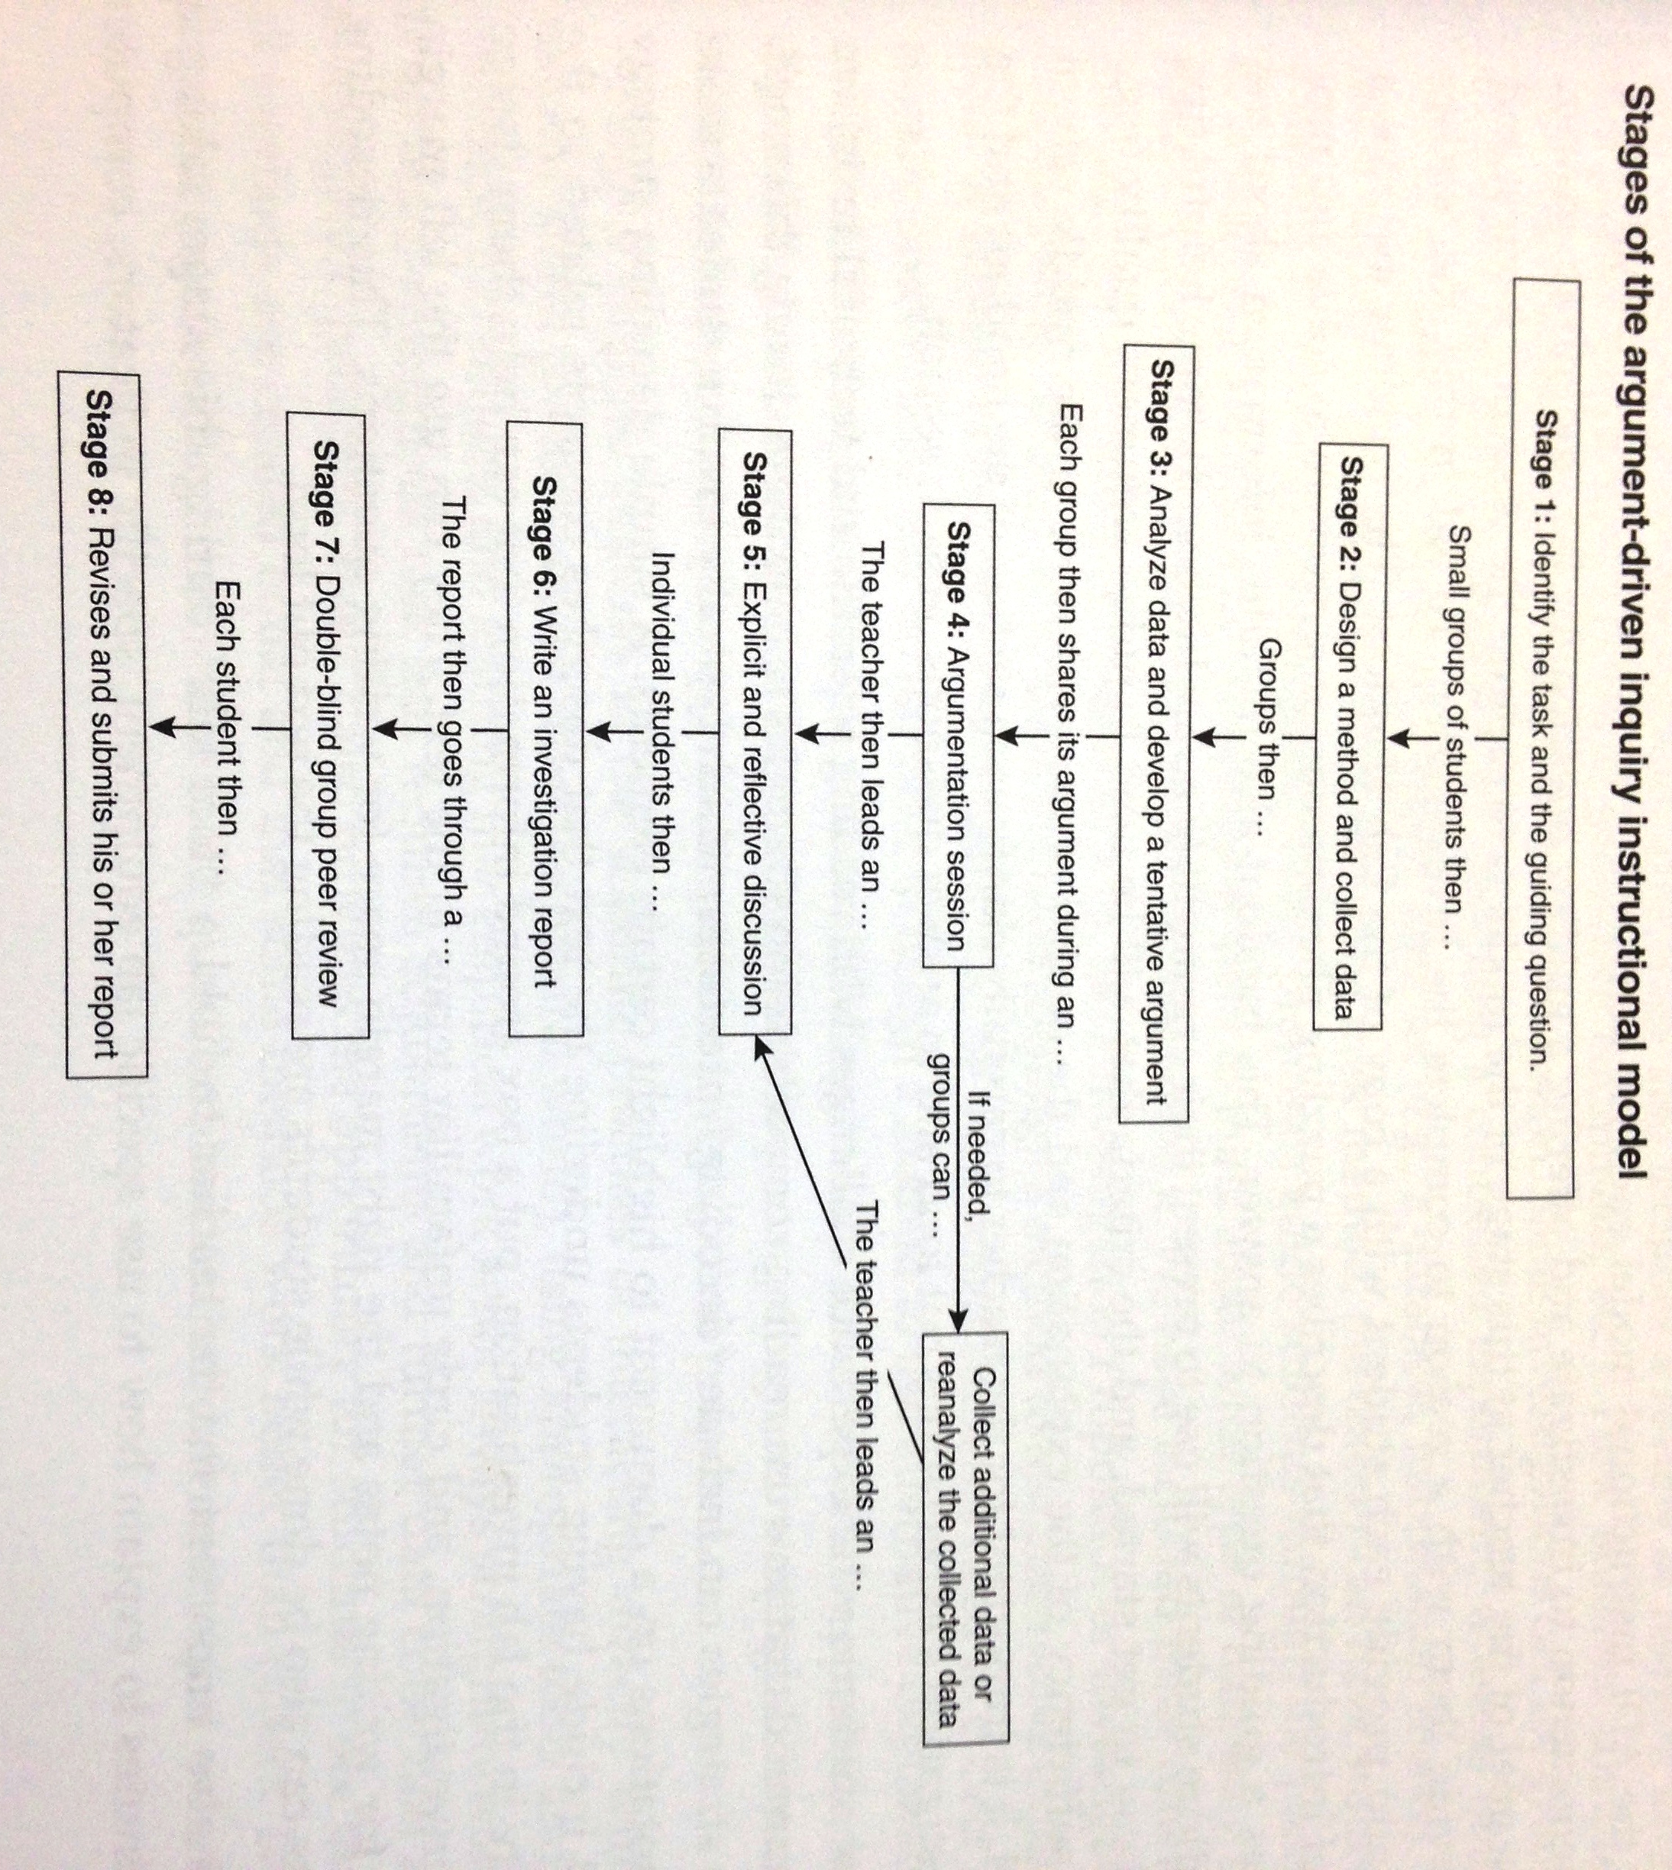
Source: Argument-Driven Inquiry in Life Science: Lab Investigations for Grades 6-8. NSTA Press, 2015.

