How to View the 2017 Solar Eclipse Safely
A solar eclipse occurs when the moon blocks any part of the sun. On Monday, August 21, 2017, a solar eclipse will be visible (weather permitting) across all of North America. The whole continent will experience a partial eclipse lasting 2 to 3 hours. Halfway through the event, anyone within a roughly 70-mile-wide path from Oregon to South Carolina (https://go.nasa.gov/2pC0lhe (link is external)) will experience a brief total eclipse, when the moon completely blocks the sun’s bright face for up to 2 minutes 40 seconds, turning day into night and making visible the otherwise hidden solar corona — the sun’s outer atmosphere — one of nature’s most awesome sights. Bright stars and planets will become visible as well.
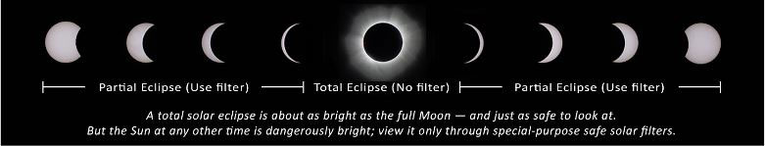
Looking directly at the sun is unsafe except during the brief total phase of a solar eclipse (“totality”), when the moon entirely blocks the sun’s bright face, which will happen only within the narrow path of totality (https://go.nasa.gov/2pC0lhe (link is external)).
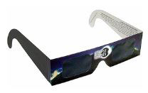
The only safe way to look directly at the uneclipsed or partially eclipsed sun is through special-purpose solar filters, such as “eclipse glasses” (example shown at left) or hand-held solar viewers. Homemade filters or ordinary sunglasses, even very dark ones, are not safe for looking at the sun. To date five manufacturers have certified that their eclipse glasses and handheld solar viewers meet the ISO 12312-2 international standard for such products: American Paper Optics, Baader Planetarium (AstroSolar Silver/Gold film only), Rainbow Symphony, Thousand Oaks Optical, and TSE 17.

- Always inspect your solar filter before use; if scratched or damaged, discard it. Read and follow any instructions printed on or packaged with the filter. Always supervise children using solar filters.
- Stand still and cover your eyes with your eclipse glasses or solar viewer before looking up at the bright sun. After glancing at the sun, turn away and remove your filter — do not remove it while looking at the sun.
- Do not look at the uneclipsed or partially eclipsed sun through an unfiltered camera, telescope, binoculars, or other optical device. Similarly, do not look at the sun through a camera, a telescope, binoculars, or any other optical device while using your eclipse glasses or hand-held solar viewer — the concentrated solar rays will damage the filter and enter your eye(s), causing serious injury. Seek expert advice from an astronomer before using a solar filter with a camera, a telescope, binoculars, or any other optical device.
- If you are within the path of totality (https://go.nasa.gov/2pC0lhe (link is external)), remove your solar filter only when the Moon completely covers the sun’s bright face and it suddenly gets quite dark. Experience totality, then, as soon as the bright sun begins to reappear, replace your solar viewer to glance at the remaining partial phases.
An alternative method for safe viewing of the partially eclipsed sun is pinhole projection. For example, cross the outstretched, slightly open fingers of one hand over the outstretched, slightly open fingers of the other. With your back to the sun, look at your hands’ shadow on the ground. The little spaces between your fingers will project a grid of small images on the ground, showing the sun as a crescent during the partial phases of the eclipse.
A solar eclipse is one of nature’s grandest spectacles. By following these simple rules, you can safely enjoy the view and be rewarded with memories to last a lifetime.

This document does not constitute medical advice. Readers with questions should contact a qualified eye-care professional.

Additional Safety Information
An eclipse is a rare and striking phenomenon you won't want to miss, but you must carefully follow safety procedures. Don't let the requisite warnings scare you away from witnessing this singular spectacle! You can experience the eclipse safely, but it is vital that you protect your eyes at all times with the proper solar filters. No matter what recommended technique you use, do not stare continuously at the sun. Take breaks and give your eyes a rest! Do not use sunglasses: they don't offer your eyes sufficient protection.

Source: https://eclipse2017.nasa.gov/safety

