Solar Eclipses for Beginners ©2009 by Fred Espenak
What is an eclipse of the Sun? What causes eclipses and why? How often do eclipses happen and when is the next eclipse of the Sun? Before we learn more about the eclipses of the Sun, we need to first talk about the Moon.
``The Moon is a cold, rocky body about 2,160 miles (3,476 km) in diameter. It has no light of its own but shines by sunlight reflected from its surface. The Moon orbits Earth about once every 29 and a half days. As it circles our planet, the changing position of the Moon with respect to the Sun causes our natural satellite to cycle through a series of phases: New Moon > New Crescent > First Quarter > Waxing Gibbous > Full Moon >
Waning Gibbous > Last Quarter > Old Crescent > New Moon (again)
The phase known as New Moon can not actually be seen because the illuminated side of the Moon is then pointed away from Earth. The rest of the phases are familiar to all of us as the Moon cycles through them month after month. When the Moon is New, it rises and sets with the Sun because it lies very close to the Sun in the sky. Although we cannot see the Moon during New Moon phase, it has a very special significance with regard to eclipses.
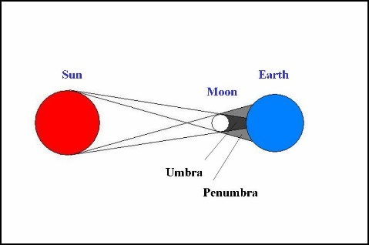
GeomThe Moon's Two Shadows
An eclipse of the Sun (or solar eclipse) can only occur at New Moon when the Moon passes between Earth and Sun. If the Moon's shadow happens to fall upon Earth's surface at that time, we see some portion of the Sun's disk covered or 'eclipsed' by the Moon. Since New Moon occurs every 29 1/2 days, you might think that we should have a solar eclipse about once a month. Unfortunately, this doesn't happen because the Moon's orbit around Earth is tilted 5 degrees to Earth's orbit around the Sun. As a result, the Moon's shadow usually misses Earth as it passes above or below our planet at New Moon. At least twice a year, the geometry lines up just right so that some part of the Moon's shadow falls on Earth's surface and an eclipse of the Sun is seen from that region. The Moon's shadow actually has two parts: 1. Penumbra-The Moon's faint outer shadow , partial solar eclipses are visible from within the penumbral shadow.2. Umbra- The Moon's dark inner shadow, total solar eclipses are visible from within the umbral shadow.
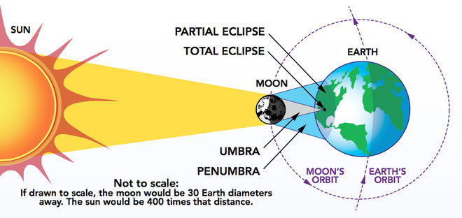
Total Solar Eclipses and the Path of Totality
If the Moon's inner or umbral shadow sweeps across Earth's surface, then a total eclipse of the Sun is seen. The track of the Moon's umbral shadow across Earth is called the Path of Totality. It is typically 10,000 miles long but only about 100 miles wide. It covers less than 1% of Earth's entire surface area. In order to see the Sun become completely eclipsed by the Moon, you must be somewhere inside the narrow path of totality.
The path of a total eclipse can cross any part of Earth. Even the North and South Poles get a total eclipse sooner or later. Just one total eclipse occurs each year or two. Since each total eclipse is only visible from a very narrow track, it is rare to see one from any single location. You'd have to wait an average of 375 years to see two total eclipses from one place. Of course, the interval between seeing two eclipses from one particular place can be shorter or longer. For instance, the last total eclipse visible from Princeton, NJ was in 1478 and the next is in 2079. That's an interval of 601 years. However, the following total eclipse from Princeton is in 2144, after a period of only 65 years.
Annular Solar Eclipses
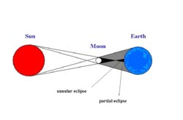
Unfortunately, not every eclipse of the Sun is a total eclipse. Sometimes, the Moon is too small to cover the entire Sun's disk. To understand why, we need to talk about the Moon's orbit around Earth. That orbit is not perfectly round but is oval or elliptical in shape. As the Moon orbits our planet, its distance varies from about 221,000 to 252,000 miles. This 13% variation in the Moon's distance makes the Moon's apparent size in our sky vary by the same amount. When the Moon is on the near side of its orbit, the Moon appears larger than the Sun. If an eclipse occurs at that time, it will be a total eclipse. However, if an eclipse occurs while the Moon is on the far side of its orbit, the Moon appears smaller than the Sun and can't completely cover it. Looking down from space, we would see that the Moon's umbral shadow is not long enough to reach Earth. Instead, the antumbra shadow reaches Earth. The track of the antumbra is called the path of annularity. If you are within this path, you will see an eclipse where a ring or annulus of bright sunlight surrounds the Moon at the maximum phase. Annularity can last as long as a dozen minutes, but is more typically about half that length. Since the annular phase is so bright, the Sun's gorgeous corona remains hidden from view.
The "Oddball" Hybrid Eclipse
There's one more type of solar eclipse to mention and its a real oddball. Under rare circumstances, a total eclipse can change to an annular eclipse or vice versa along different sections of the eclipse path. This happens when the curvature of Earth brings different points of the path into the umbral (total) and antumbral (annular) shadows, respectively. Hybrid eclipses are sometimes called annular/total eclipses. The last hybrid eclipse was in 2005 and the next one is in 2013.
Solar Eclipse Frequency and Future Eclipses
During the five thousand year period 2000 BCE to 3000 CE, planet Earth experiences 11,898 solar eclipses as follows:
Solar Eclipses: 2000 BCE to +3000 CE |  |  |  | This works out to an average 2.4 eclipses each year. Actually, the number of solar eclipses in a single year can range from 2 to 5. Nearly 3/4 of the time there are 2 eclipses in a year. On the other hand, it is quite rare to have 5 solar eclipses in a single year. The last time it happened was in 1935 and the next time is 2206. Typically there is 1 total eclipse every 1 to 2 years. Although it is possible to have 2 total eclipses in a single year, it is quite rare. Examples of years containing 2 total eclipses are 1712, 1889, 2057 and 2252.
Eclipse Type | Symbol | Number | Percent
All Eclipses | - | 11898 | 100.0%
Partial | P | 4200 | 35.3%
Annular | A | 3956 | 33.2%
Total | T | 3173 | 26.7%
Hybrid | H | 569 | 4.8%

